

**LAB 3 Report**

**Dropbox**

[**https://github.com/varun1524/OnlineFileManagement_SpringBoot**](https://github.com/varun1524/OnlineFileManagement_SpringBoot)

**By:**

**Varun Shah**

Table of Contents

1. Dropbox 3

1.1. Introduction 3

1.2. System Design 3

1.3. Results 5

1.4. Performance Test 20

1.5. Performance Analysis 25

1.6. Unit Test 26

2. GitHub Link 34

# Dropbox

Dropbox Web Application replica of Dropbox to demonstrate Rest Web Services

## Introduction

Goal:

Designing Dropbox Web API to demonstrate Reacts client with spring boot server using MySQL Database

Purpose:

Purpose of this system is to demonstrate stateless REST web service by integrating it with spring boot server by building Dropbox API with following operations:

* Basic Users functionalities
  + Sign up new user (first, name, last name, Email and password)
  + Sign in existing user (Encrypt Passwords))
  + Sign out.
  + Upload files
  + List a file
  + Create a directory
  + Star a folder/directory
  + Share a folder/directory by email/name/link
* Users account should provide basic details such as:
  + About: User overview, Work and education, contact info and life events
  + Interests like music, shows and sports
* Provide Groups (share) functionalities:
  + Create group
  + Add member in a group
  + Show members in group
  + Assign access permission to a directory
  + Delete member from a group
  + Delete group
* Provide file list and activity report functionality

## System Design

Calculator API is created using following:

* React.js
* Spring Boot
* Bootstrap
* MySQL

Front-end is developed using React.js and Bootstrap for better look and feel. Components are divided in following way:

React Component App

MainPage.js

Successful login

SignUp

Login

User

Group

Activity

Profile

File

Home

Group/ :groupid

After logging in successfully user can access all the child components of User. When user logs in successfully session gets creation with user’s username and client server state will be managed by session. When session expires, user get redirected to login screen.

**Architecture**:

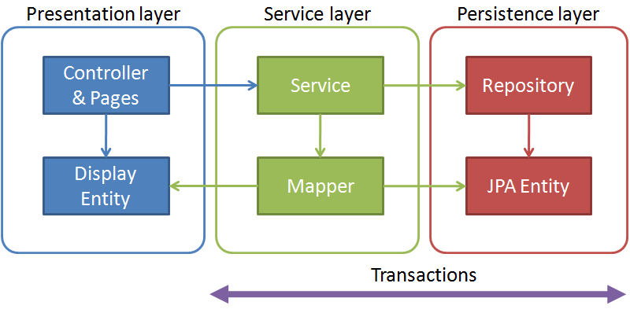

React JS

Above diagram depicts architecture followed in developing Dropbox. Spring Boot is used as a server. Spring boot is developed on top of Spring framework eliminating boilerplate coding. It allows developer to develop code without writing boilerplate codes. React connects to Spring boot server using cross origin. For each functionality separate controller is designed, which interacts to database using entity and provides data to react client. Spring Boot contains 3 Layers Presentation Layer, Service Layer and Persistence Layer. Presentation Layer contains Controller and Entity. Controller fetches requests using cross origin from react. Sends request to Service Layer and service layer completes transaction using repository (JPA Entity).

## Results

* Signup
  + Client

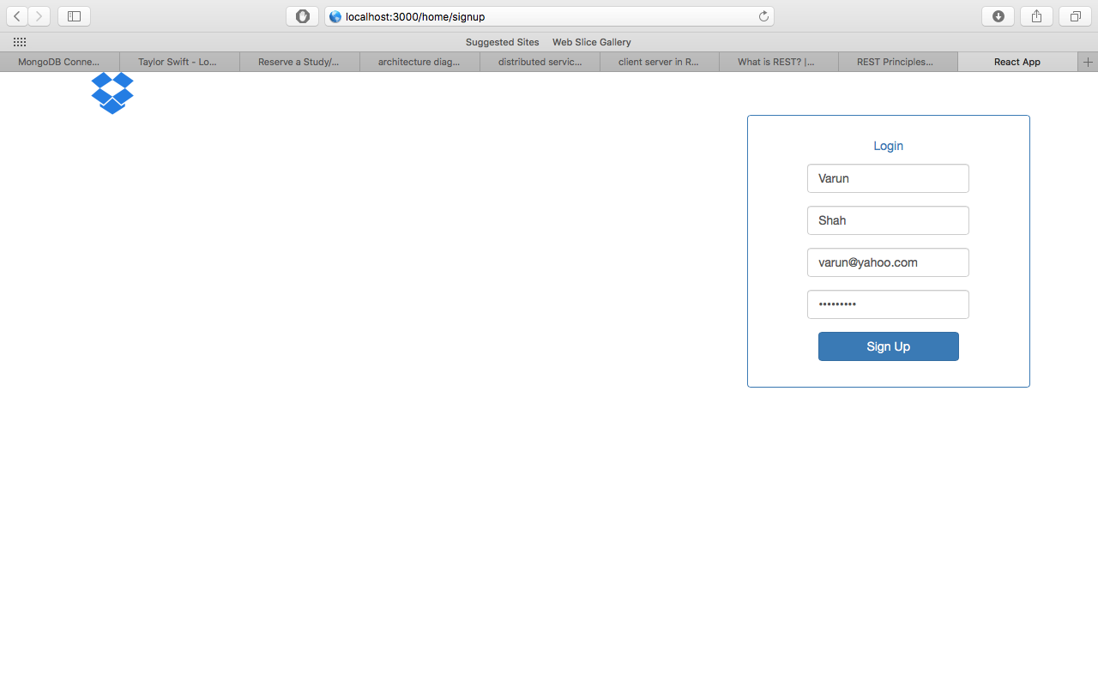

* + Server

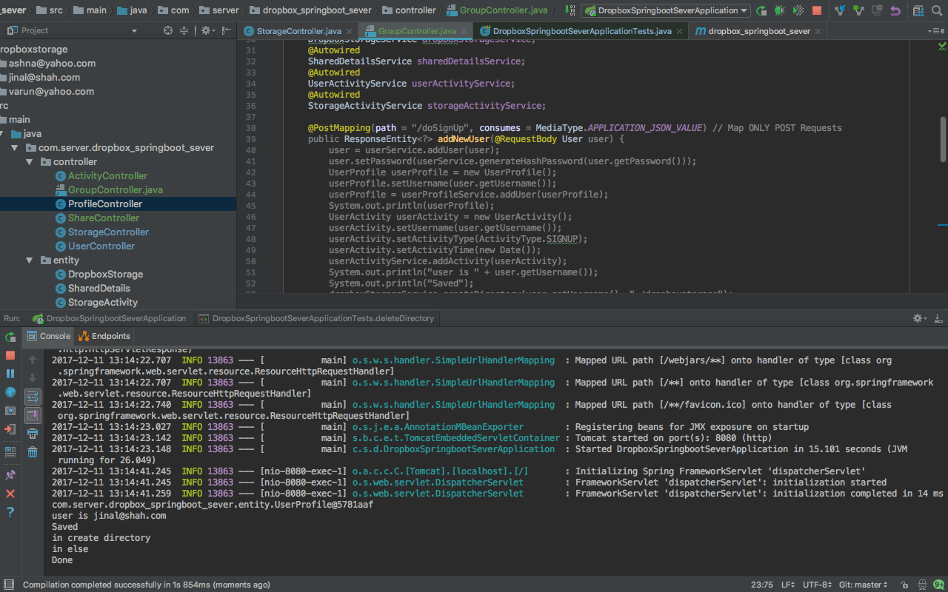

* Login
  + Client

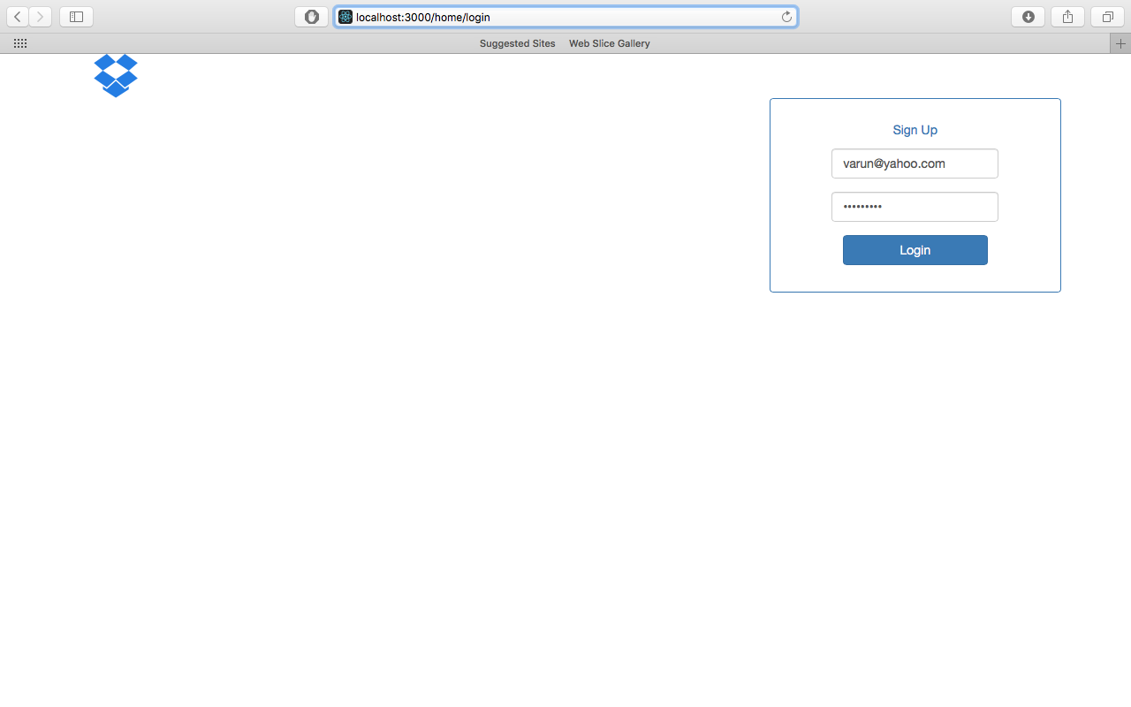

* + Server

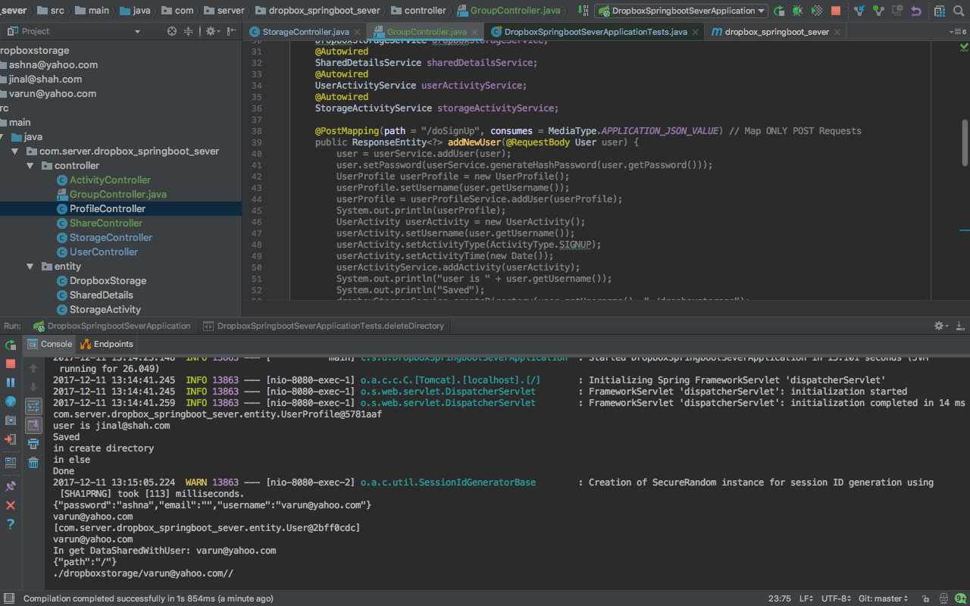

* After login User Home Screen with Starred data, data shared by user and data shared with user
  + Client

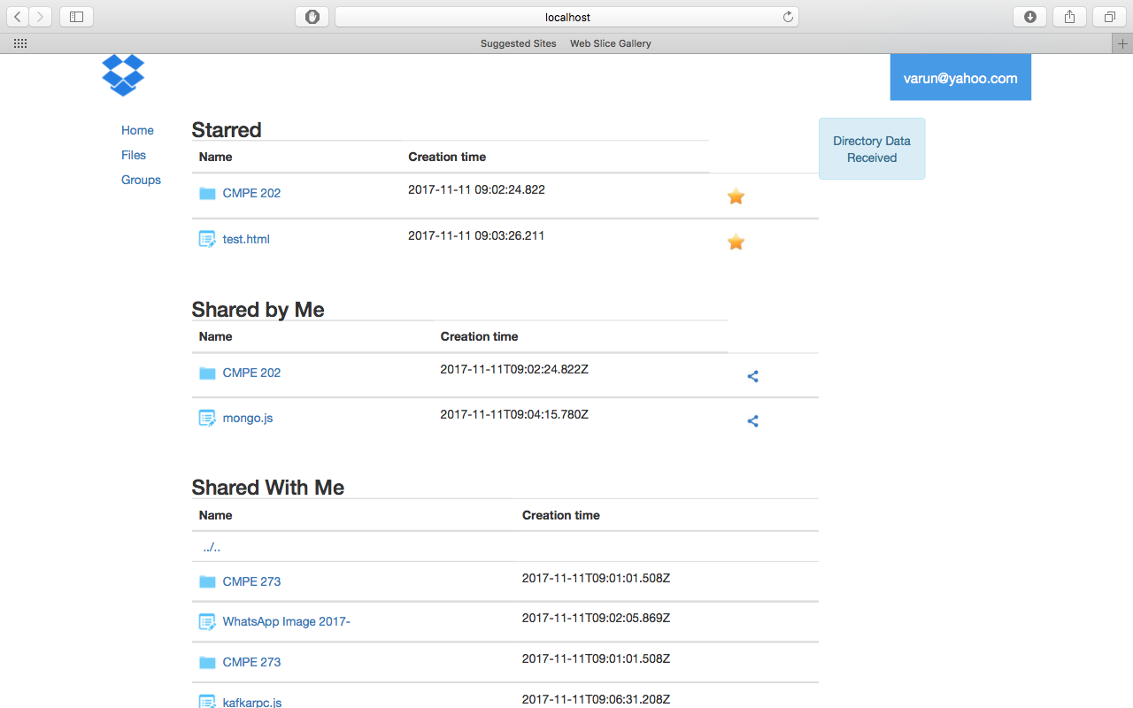

* + Server

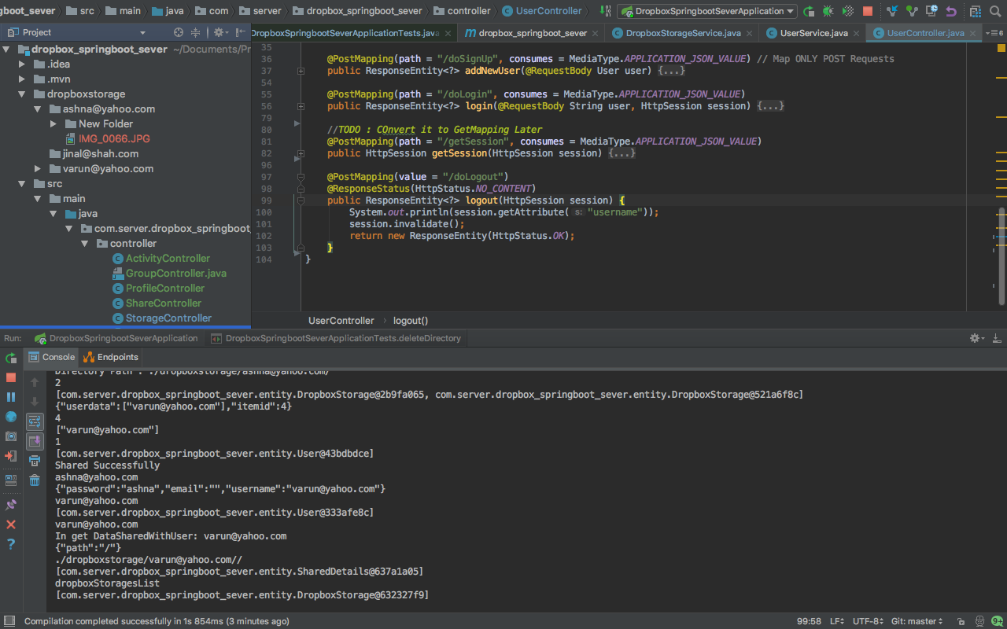

* User’s uploaded Filesystem
  + Client

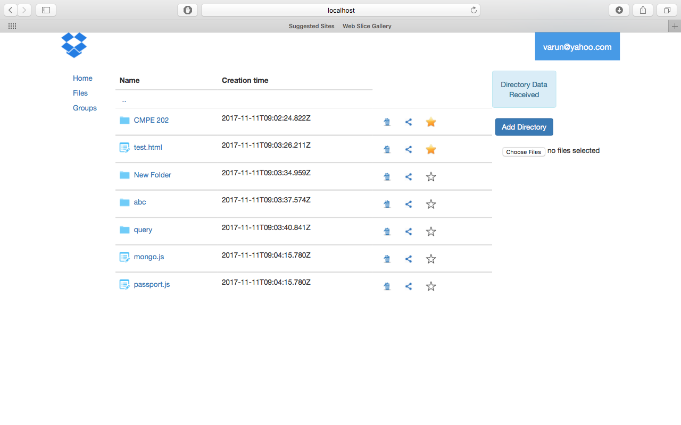

* + Server

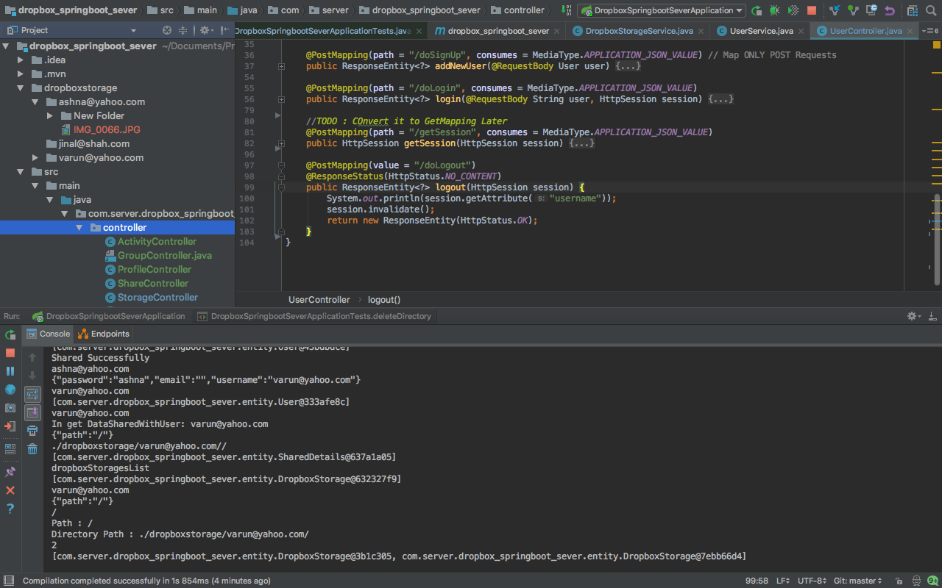

* Navigation in file system
  + Client



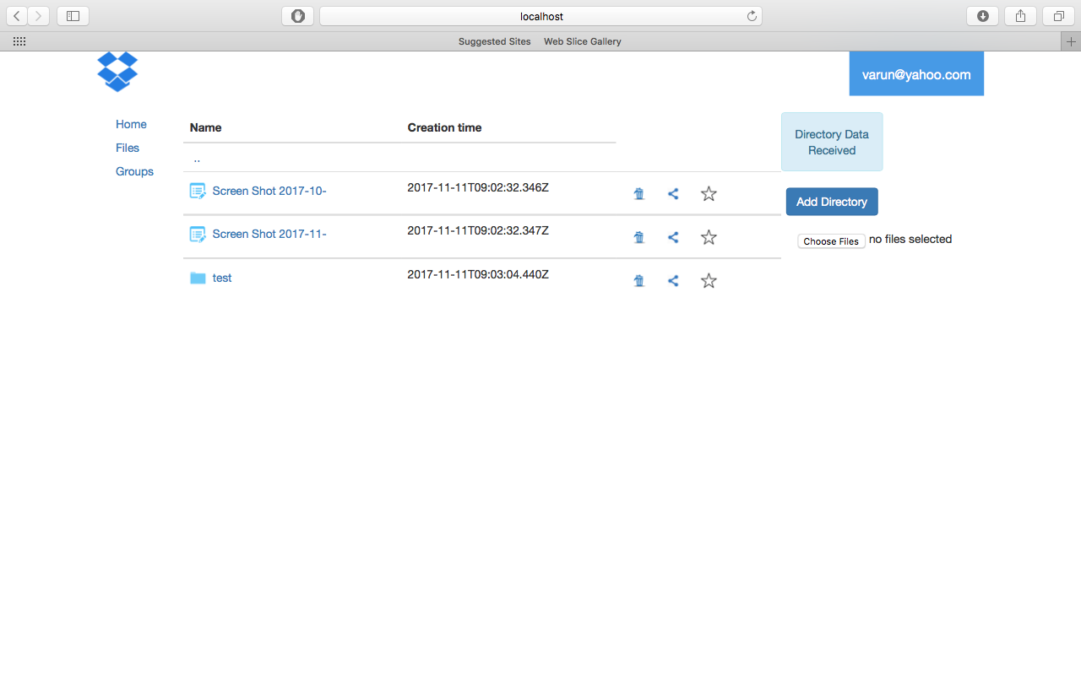

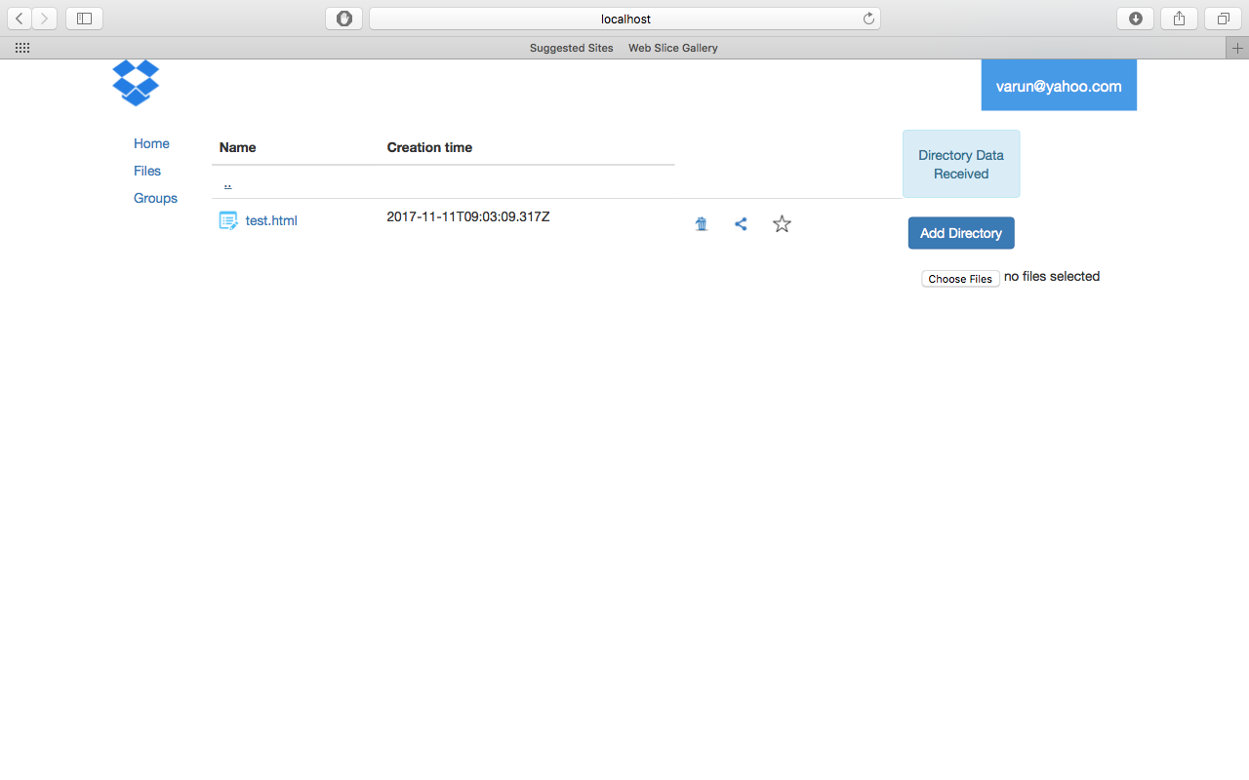

* + Server

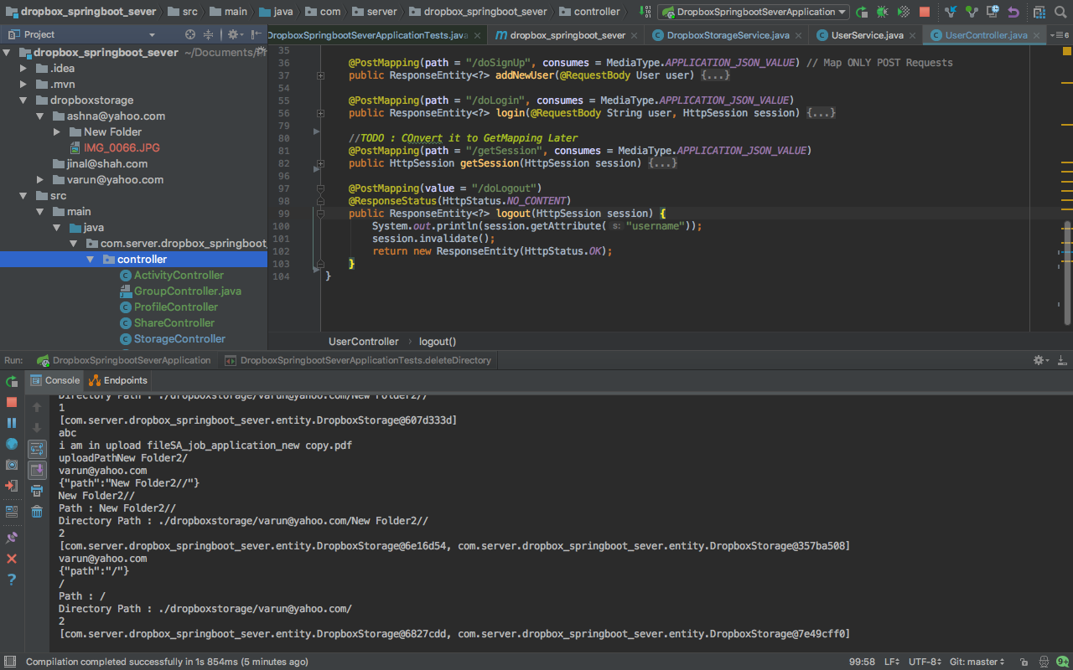

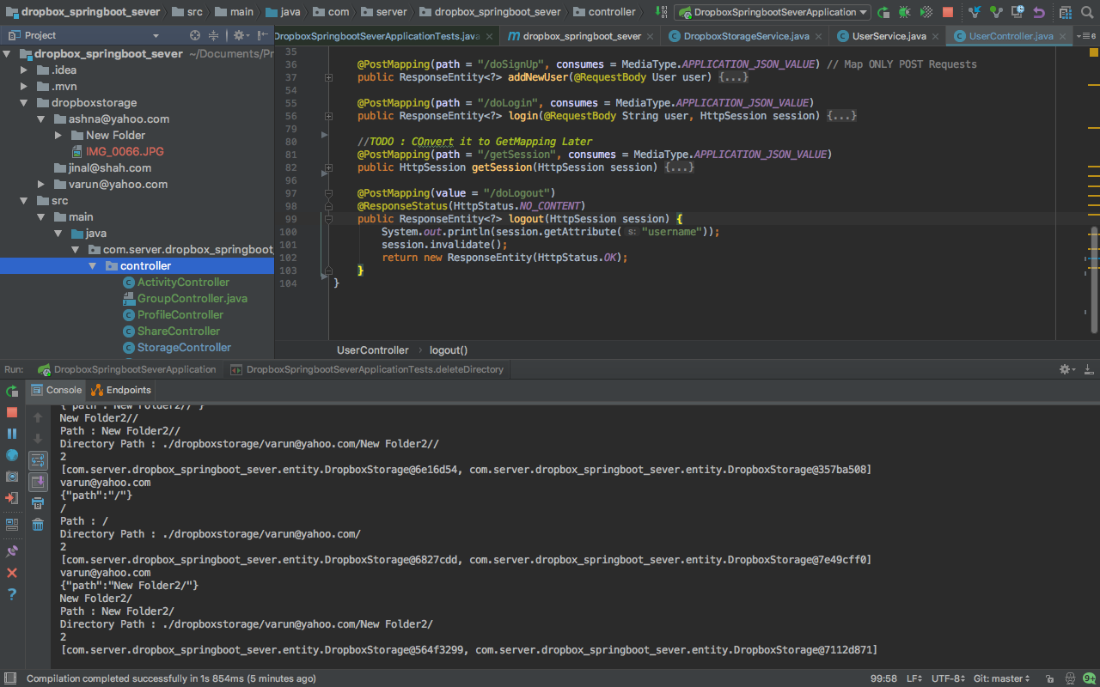

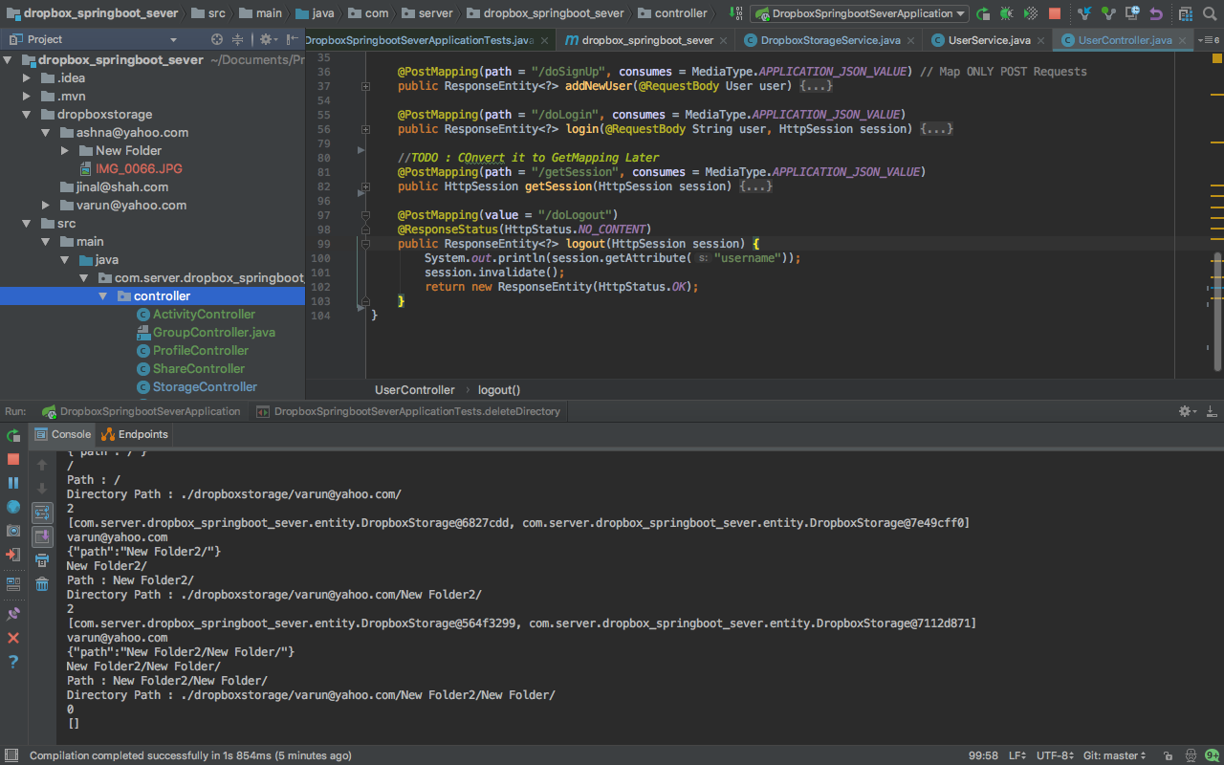

* Activity Screen
  + Client

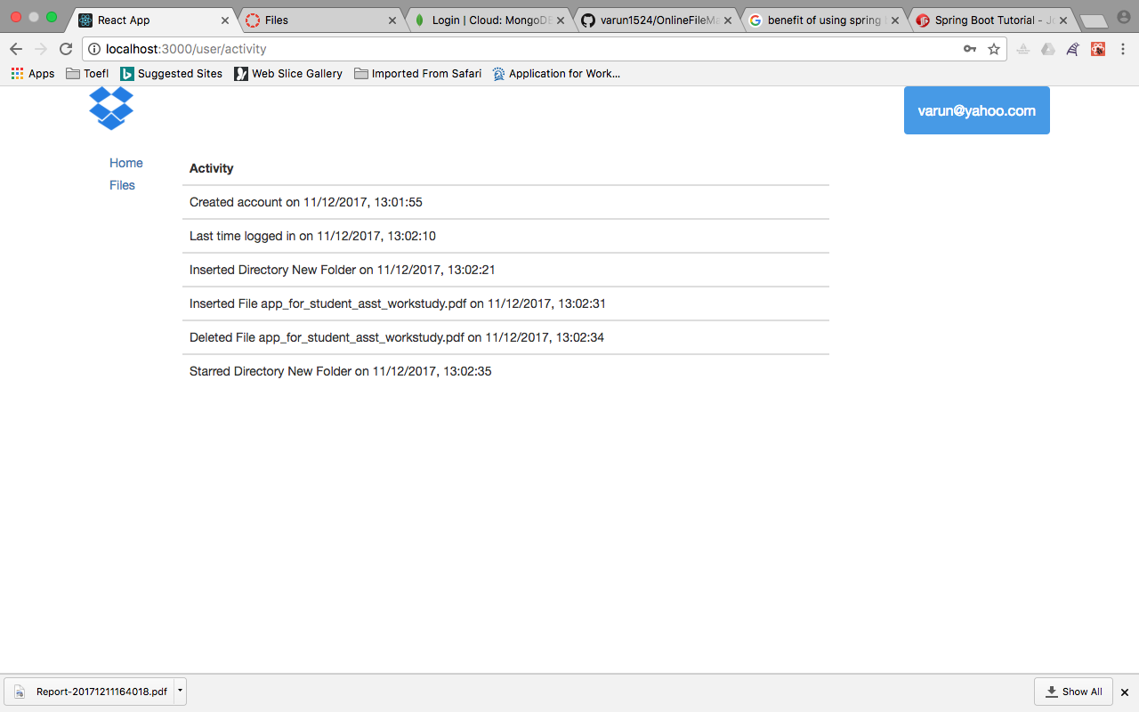

* + Server

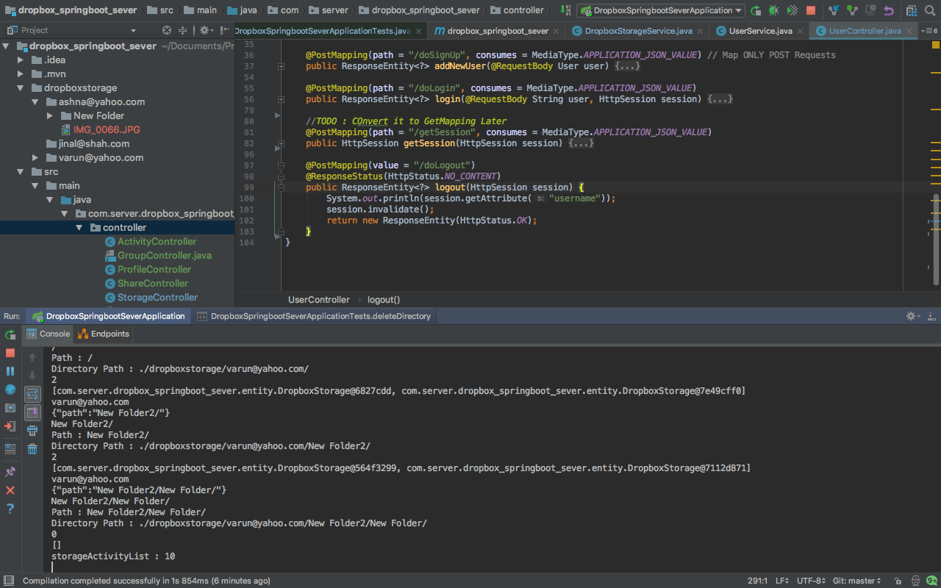

* Profile
  + Client

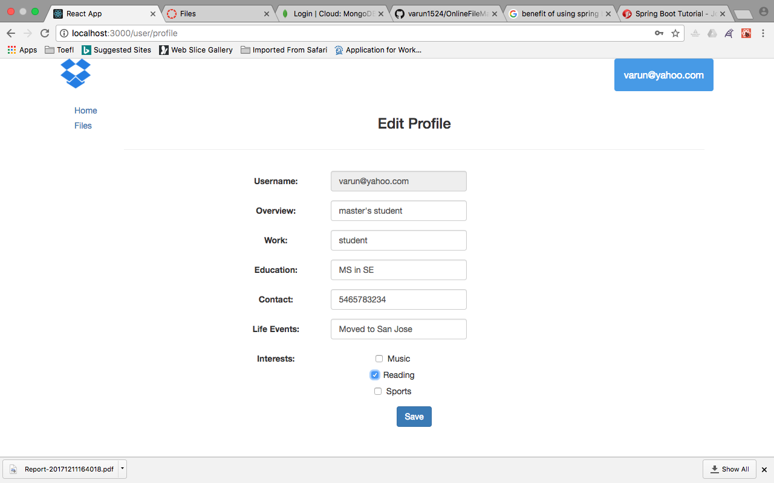

* + Server

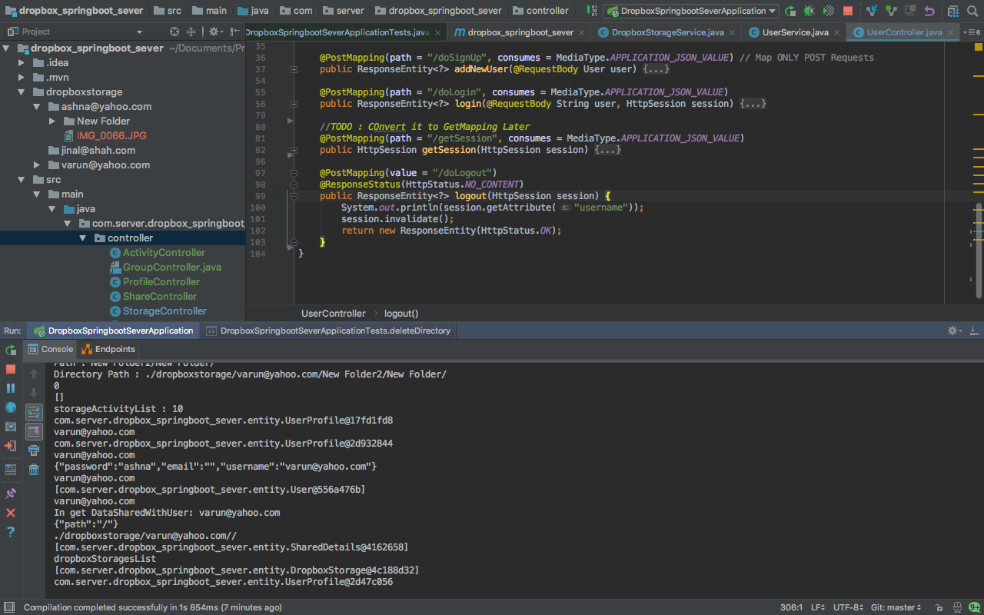

* Group

Retrieves all the groups in which user is member with the type of access and the ones where user is the group owner

* + Client

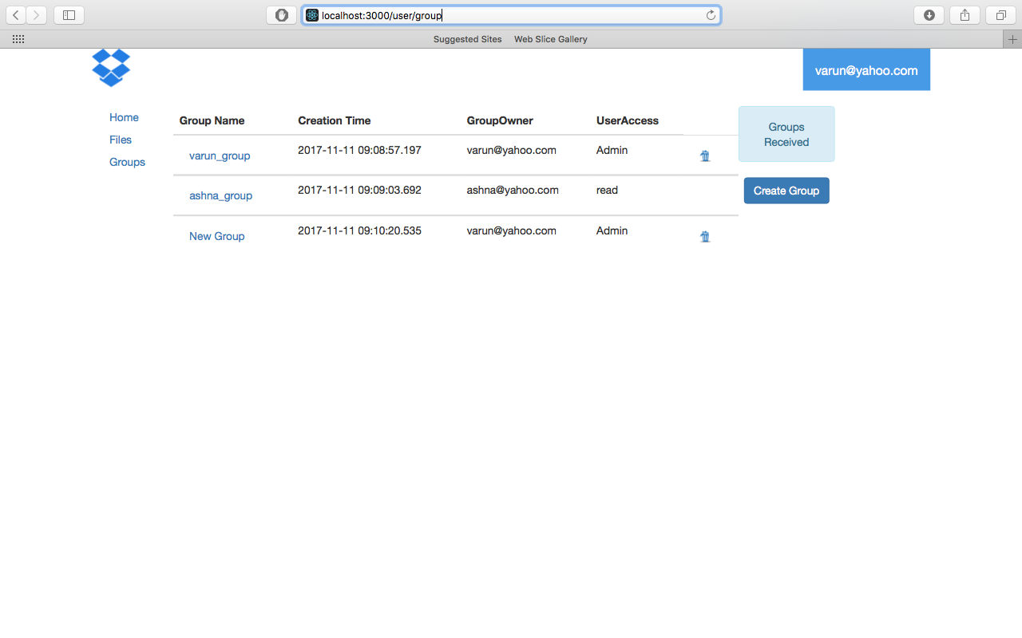

* + Server

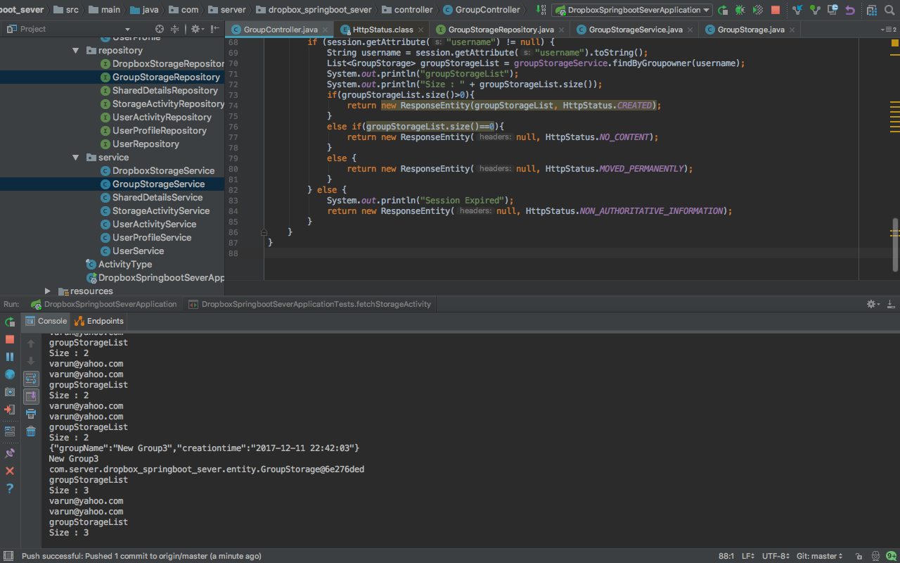

* Data in Group where user is Owner

Owner has all the rights to add/remove users and data

* + Client

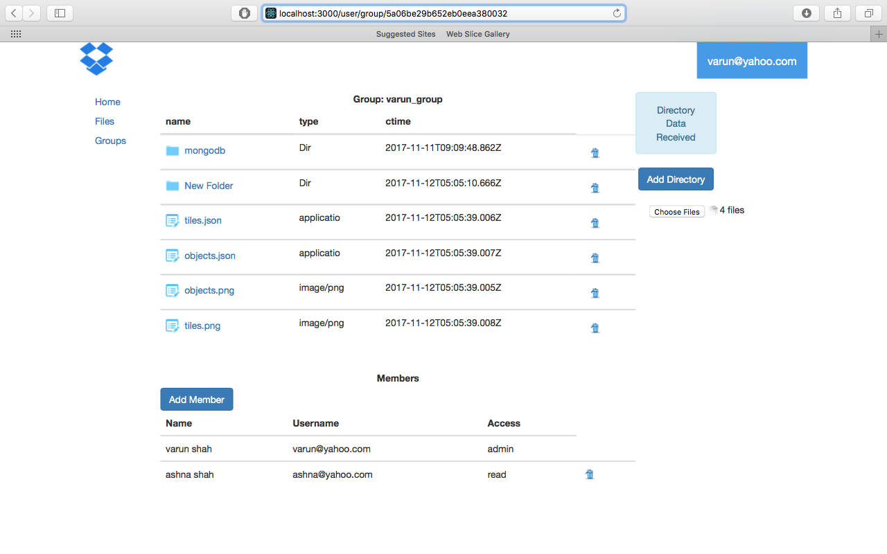

* + Server

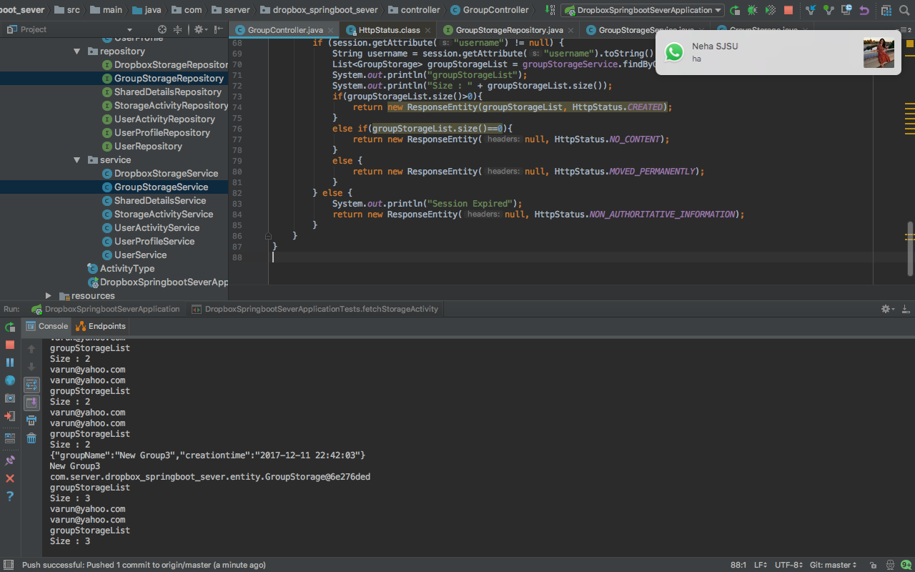

* View in Group where user is Member

Member can download data. Member cannot add members or delete data. Member can upload data only if member has the write access

* + Client

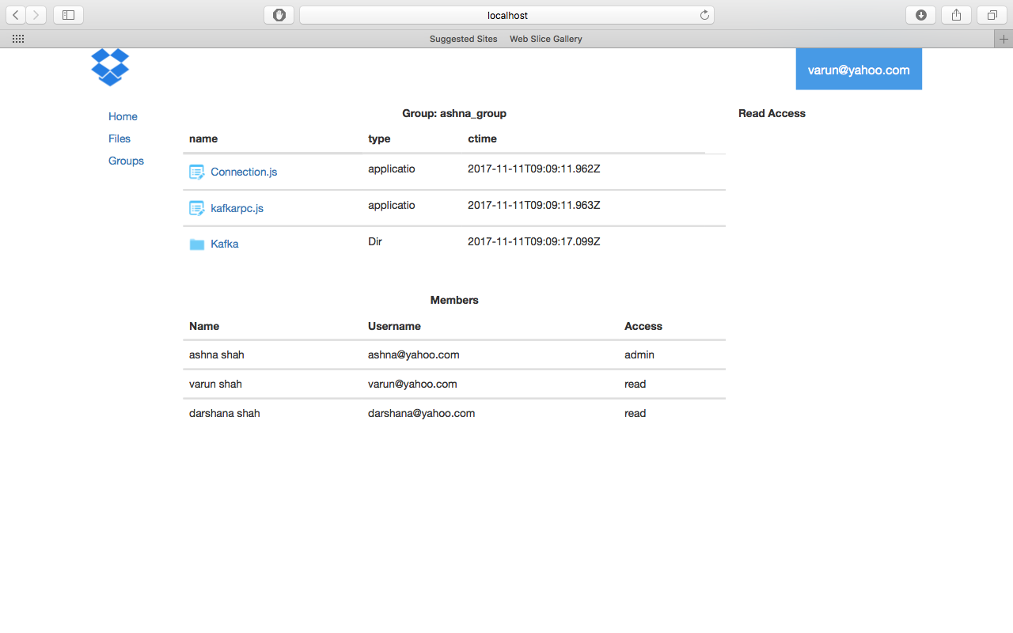

* + Server

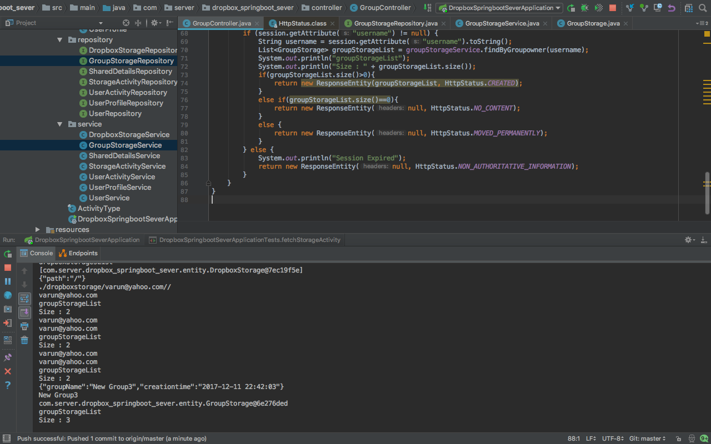

## Performance Test

* Performance Test with Spring Boot
  + 100 concurrent users

Graph Result

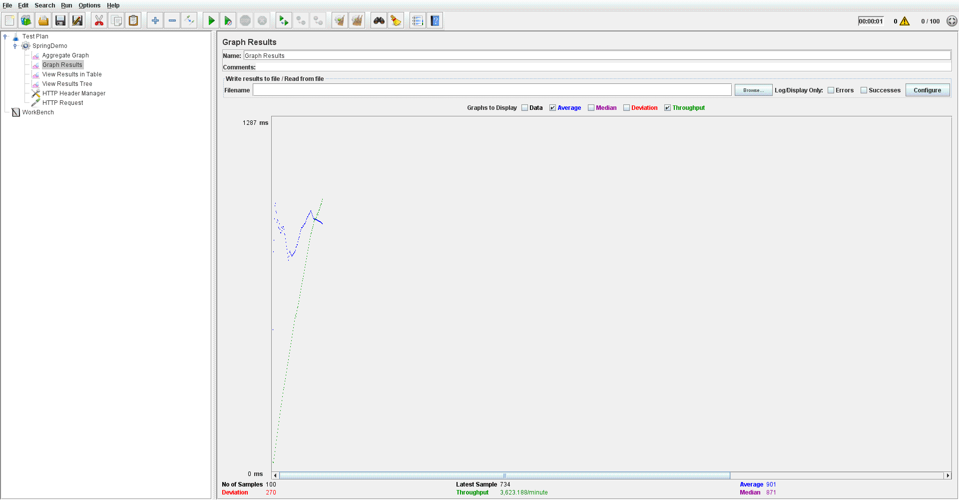

Aggregate Graph

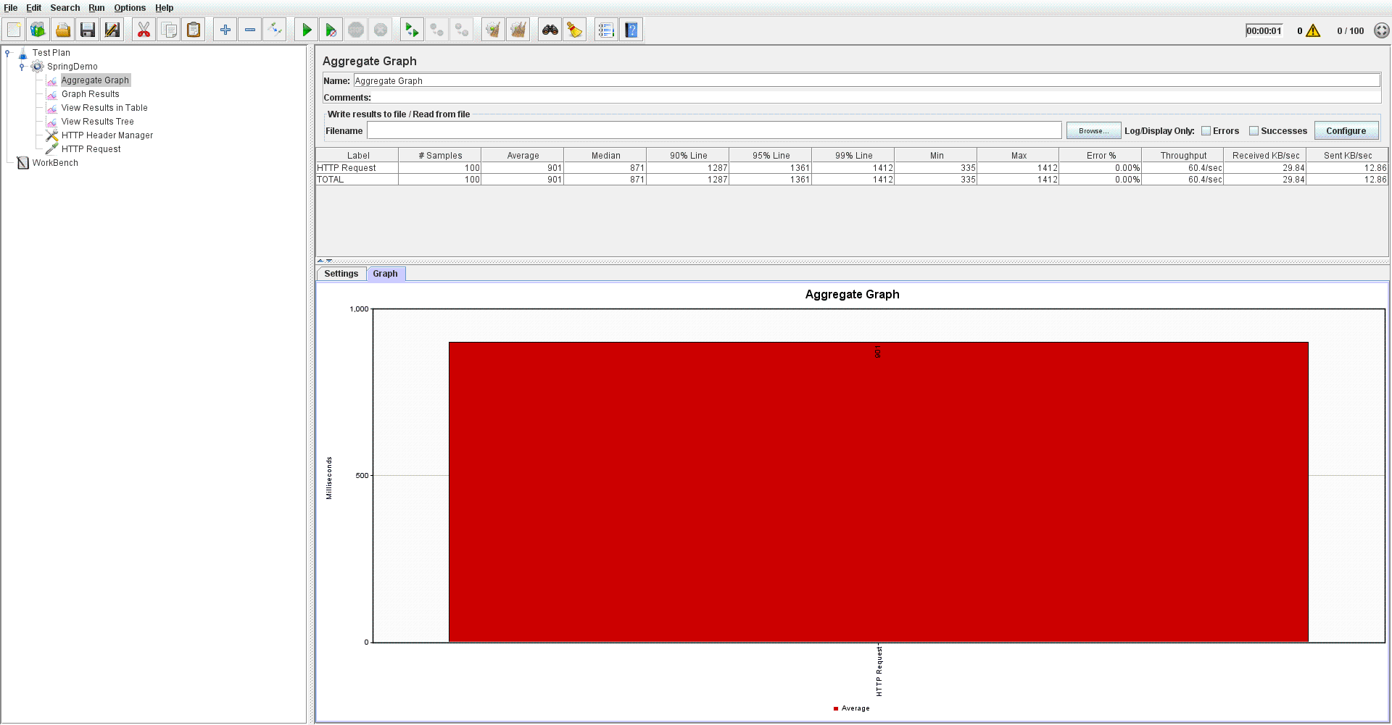

* + 200 concurrent users

Graph Result

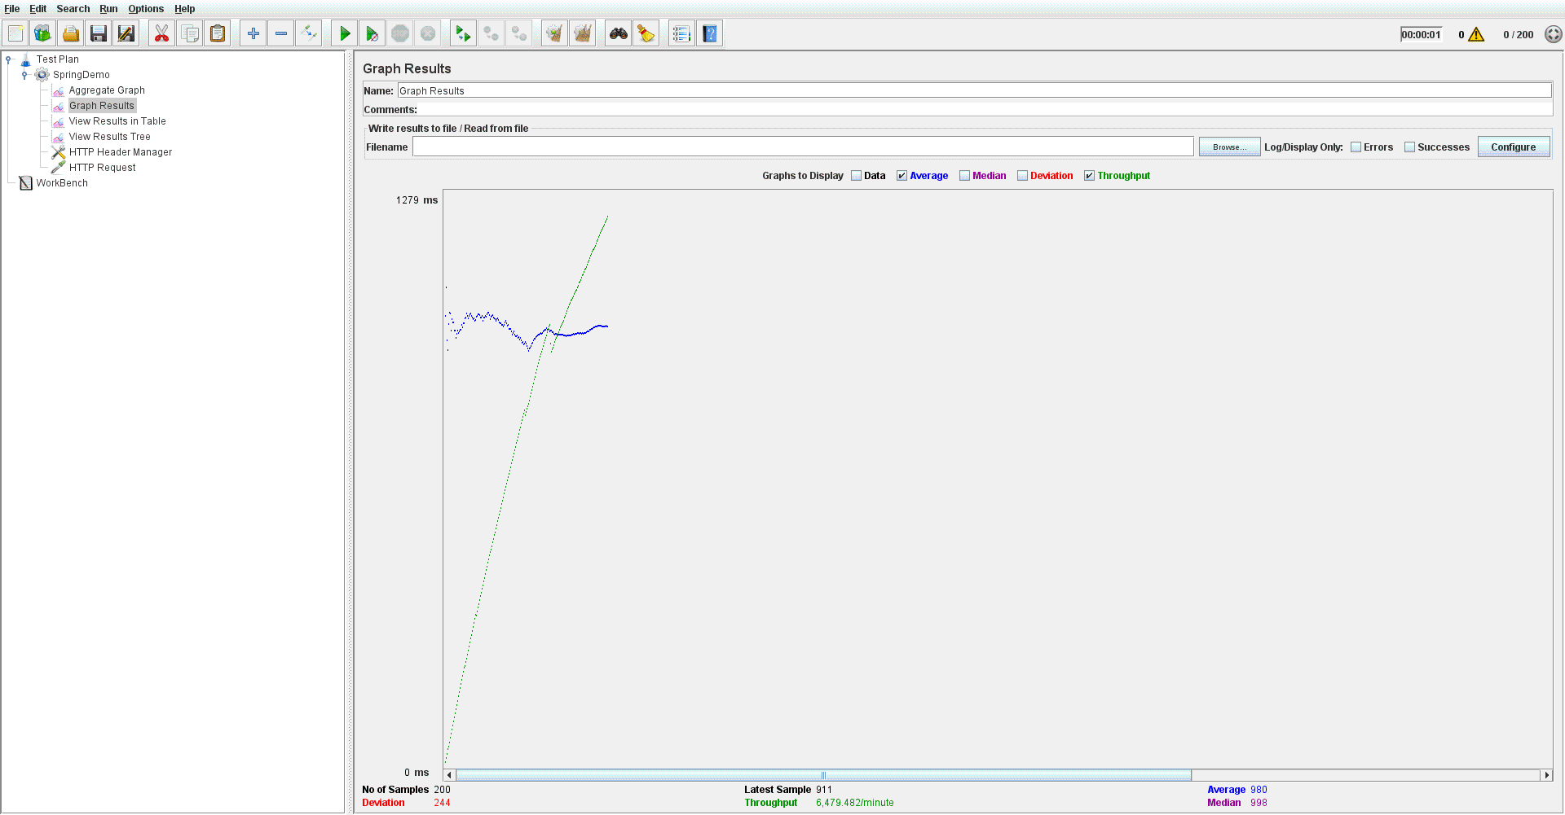

Aggregate Graph

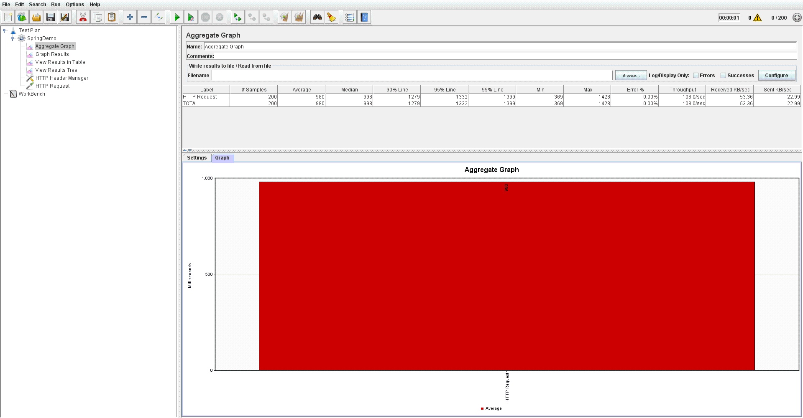

* + 300 concurrent users

Graph Result

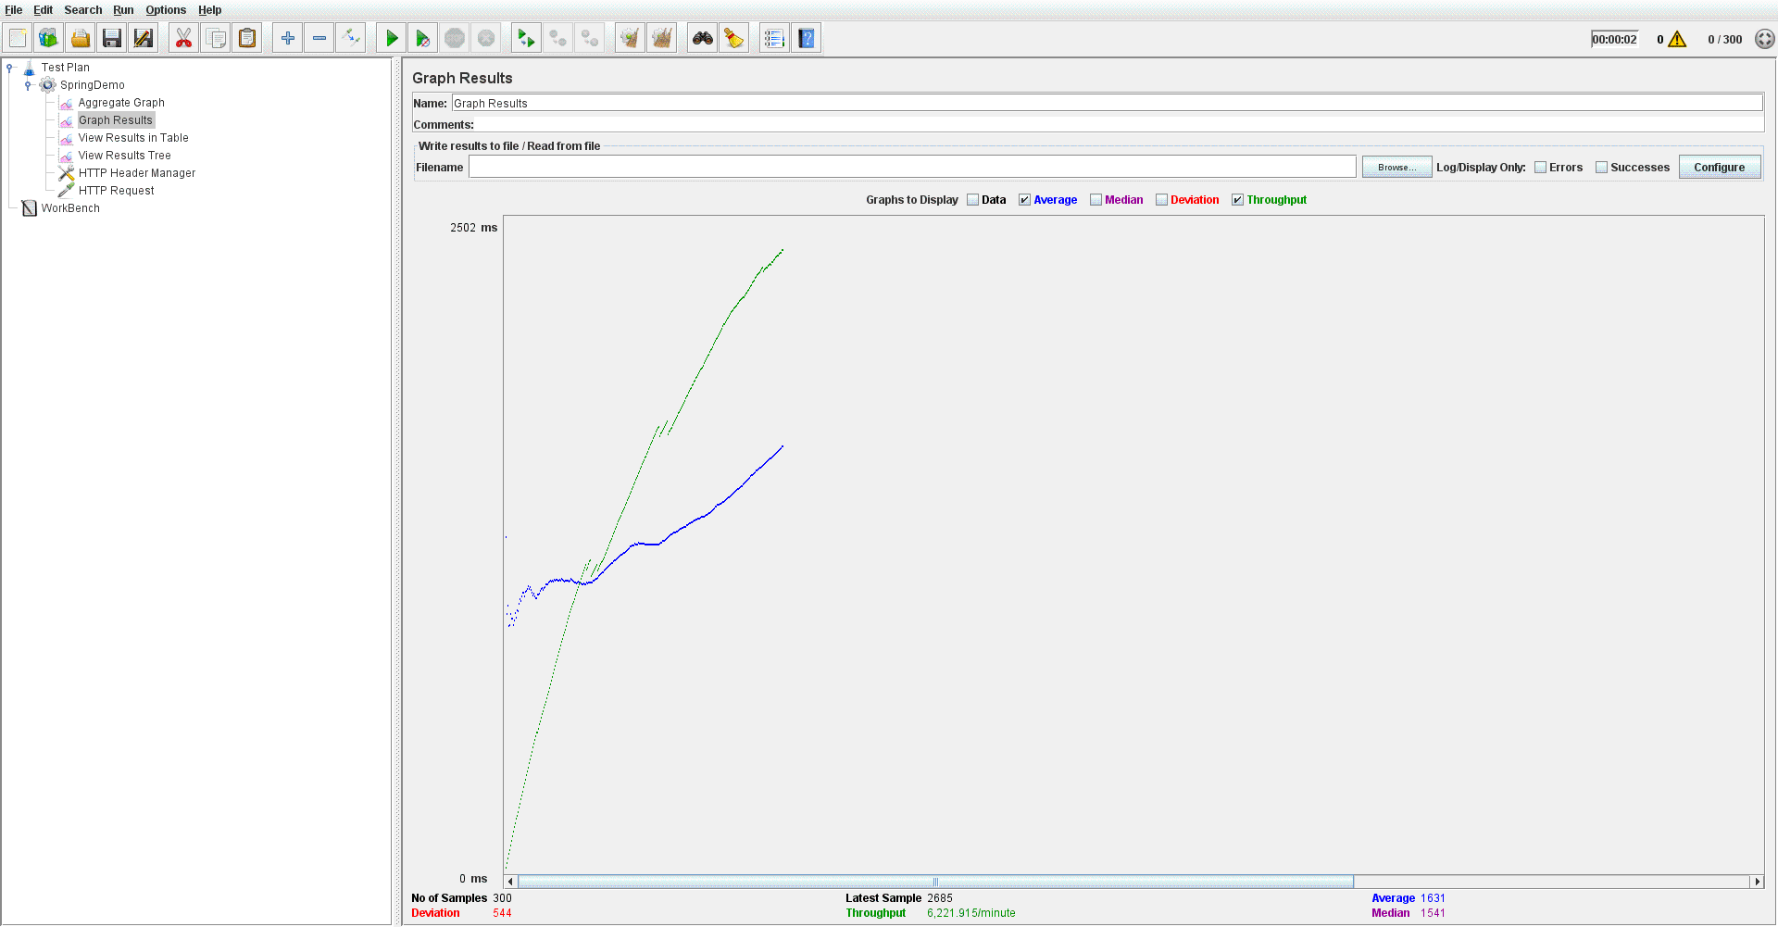

Aggregate Graph

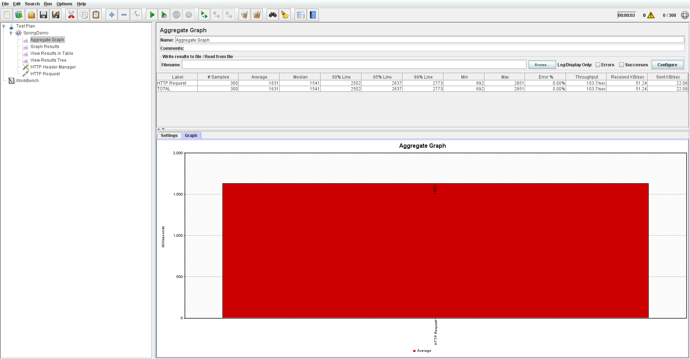

* + 400 concurrent users

Graph Result

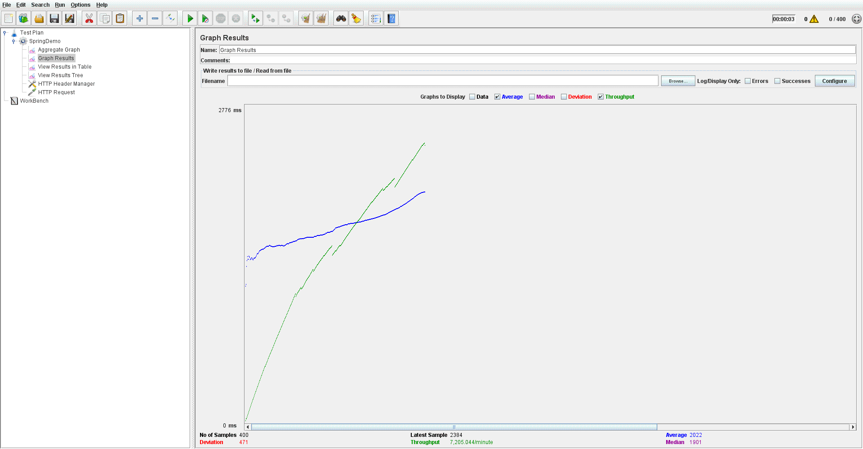

Aggregate Graph

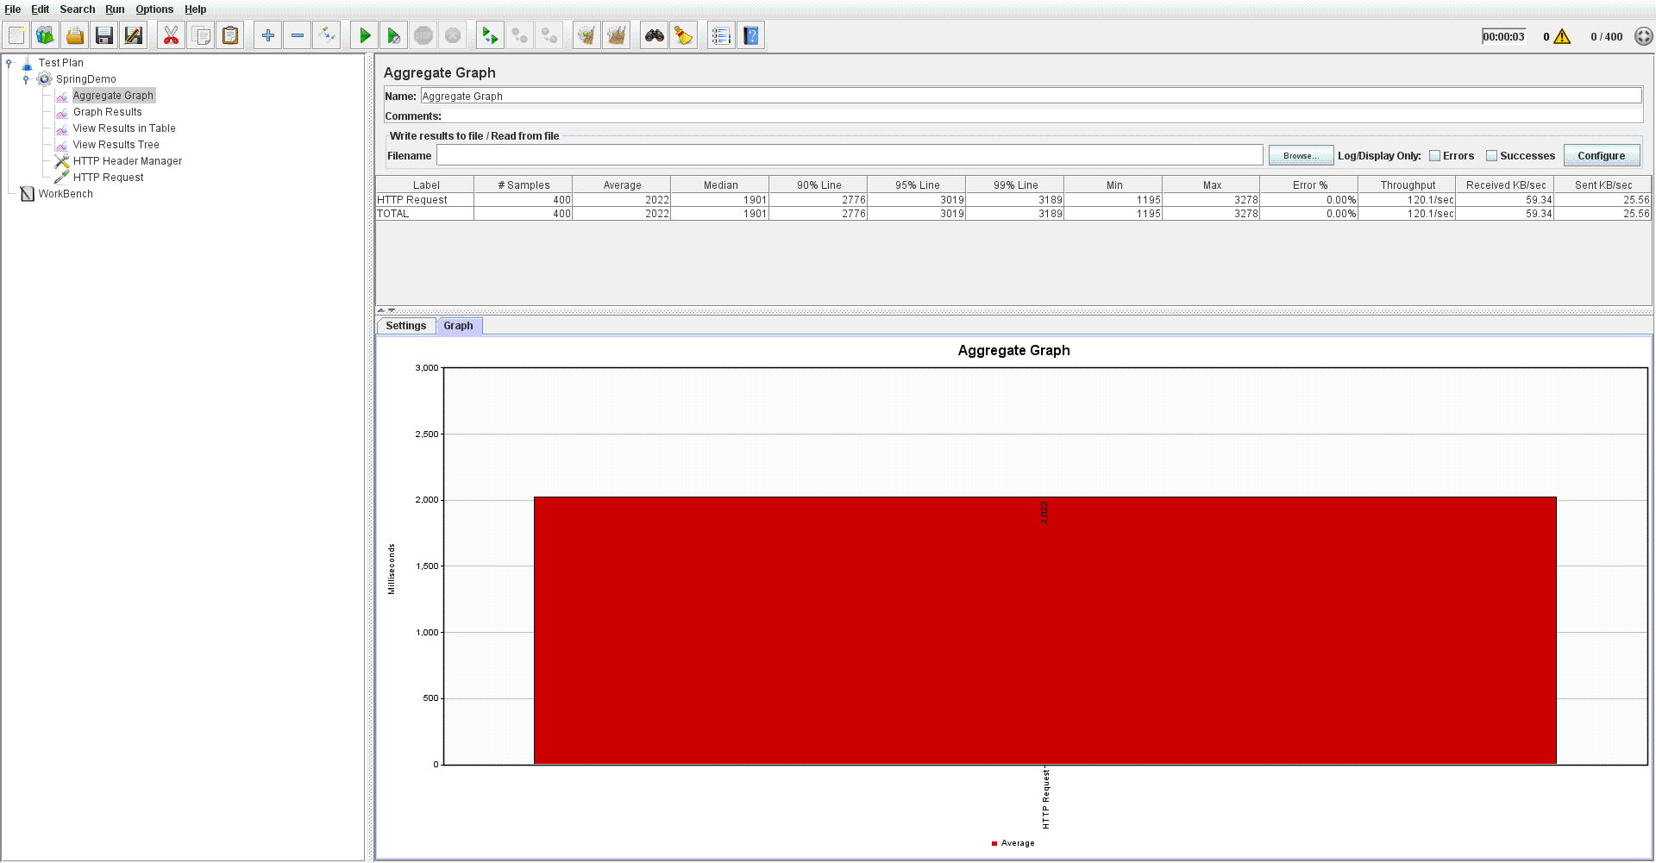

* + 500 concurrent users

Graph Result

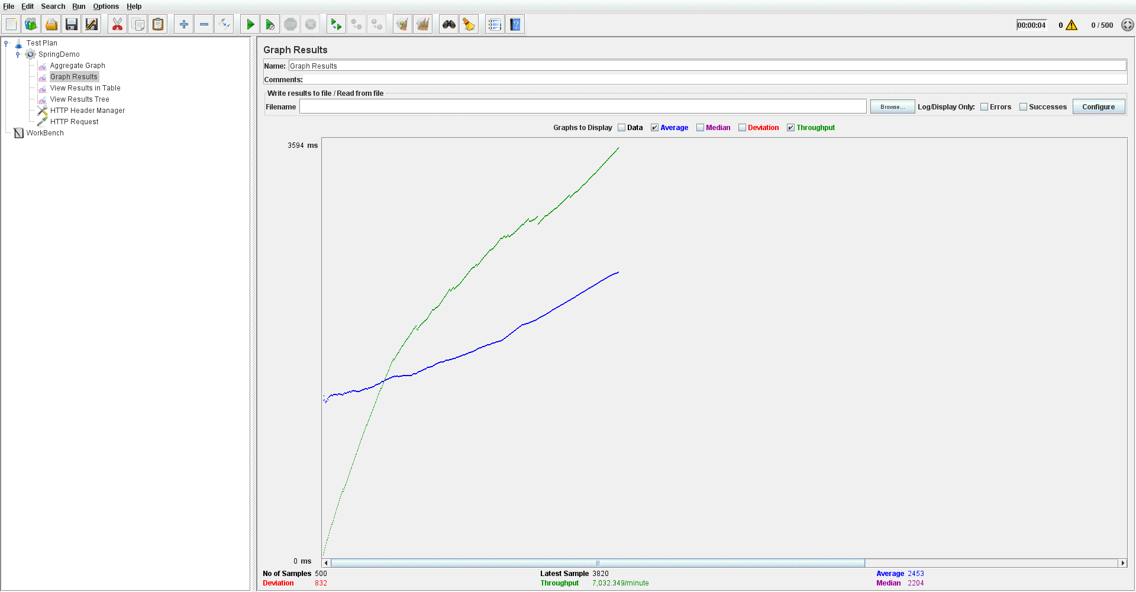

Aggregate Graph

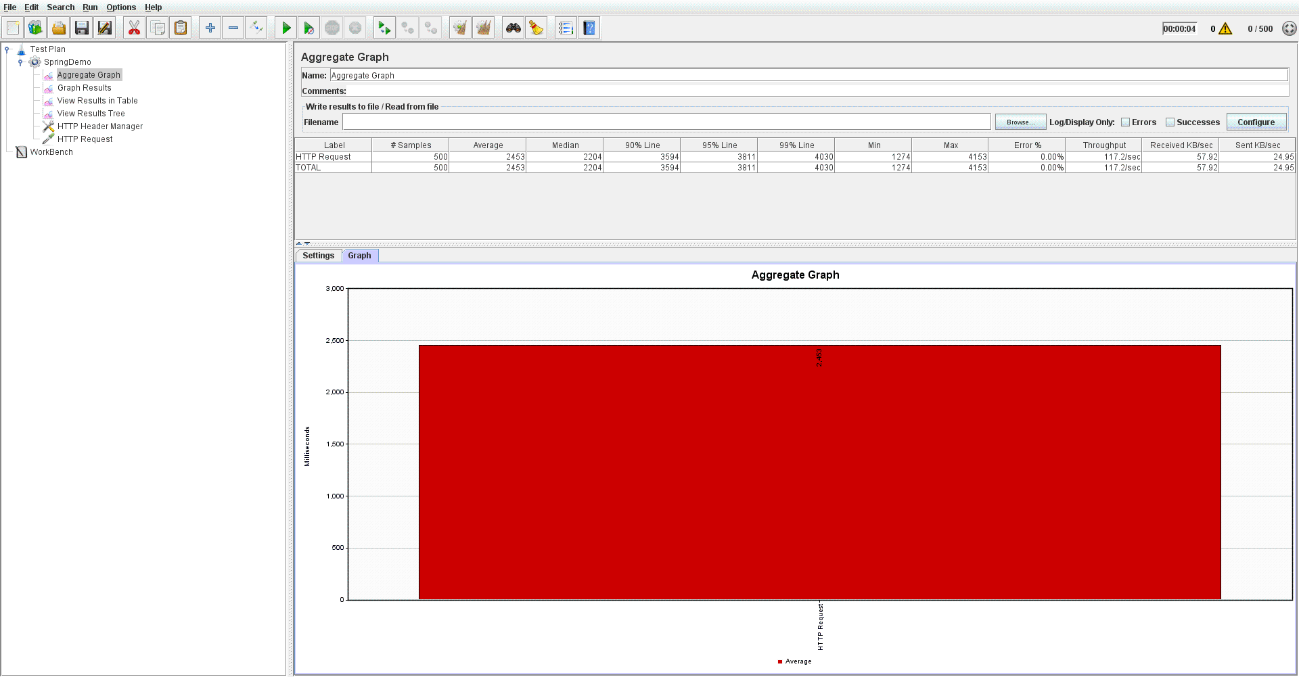

## Performance Analysis

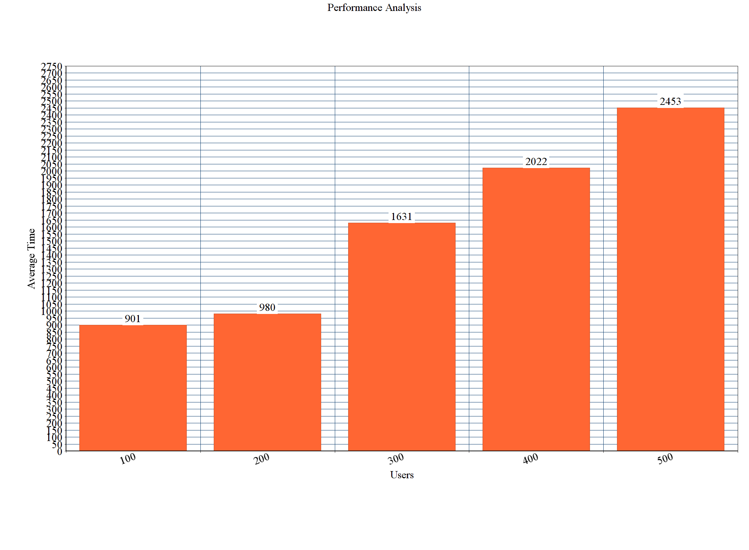

Above performance analysis graph shows that average time increases rapidly as number of users increase. For 500 concurrent users, it takes 2453 milliseconds to serve the request whereas for 100 concurrent users it takes 901 milliseconds.

## Unit Test

1. Positive Testing for Login

* Test Output

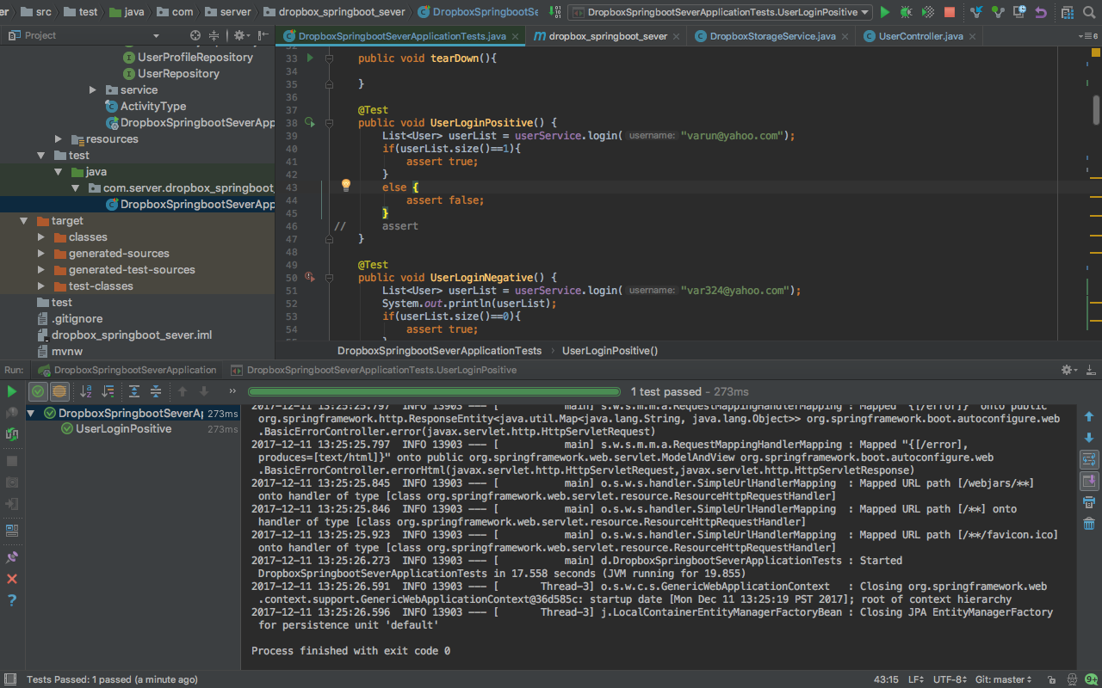

1. Negative Testing for Login

* Test Output

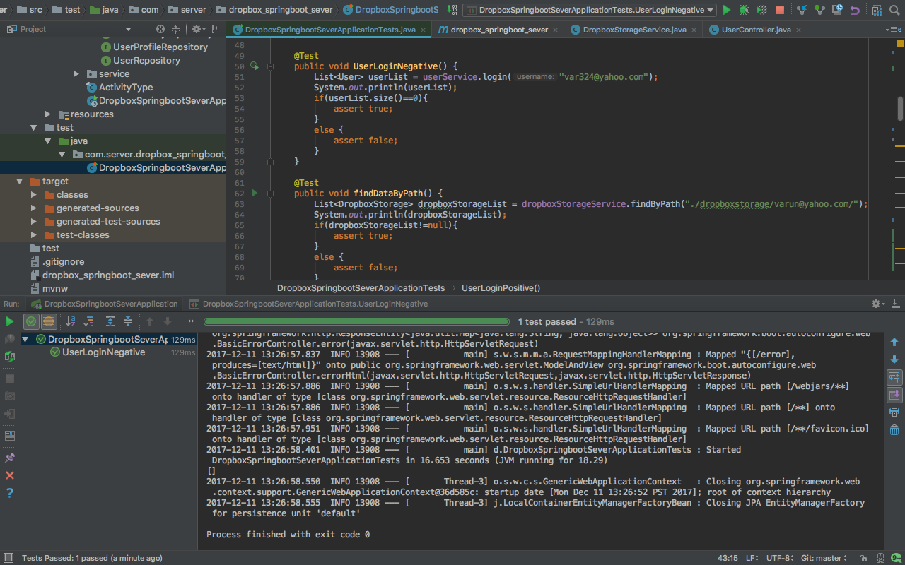

1. Finding storage data by Path

* Test Output

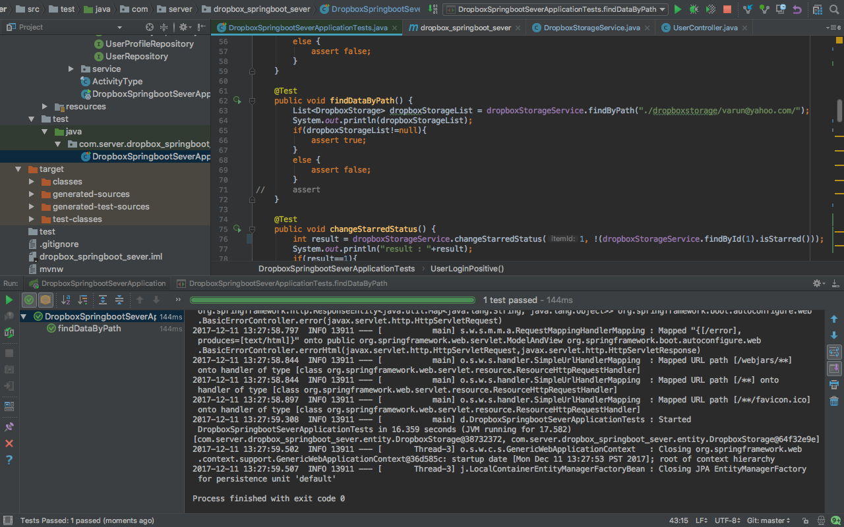

1. Change Starred Status of storage data

* Test Output

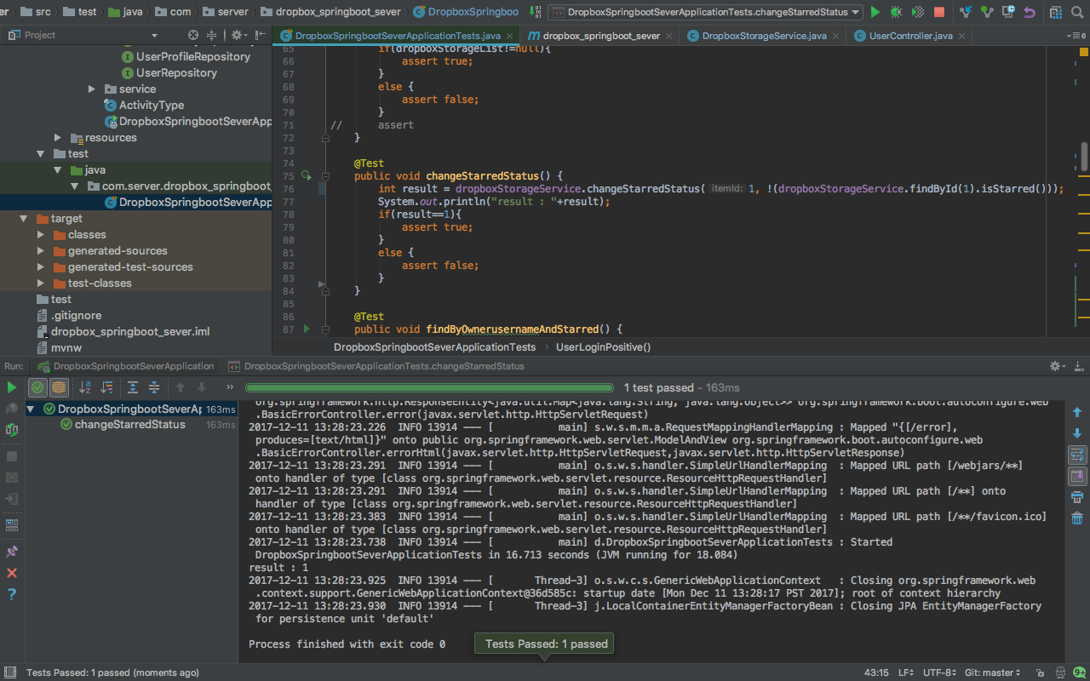

1. Find Starred data by Username

* Test Output

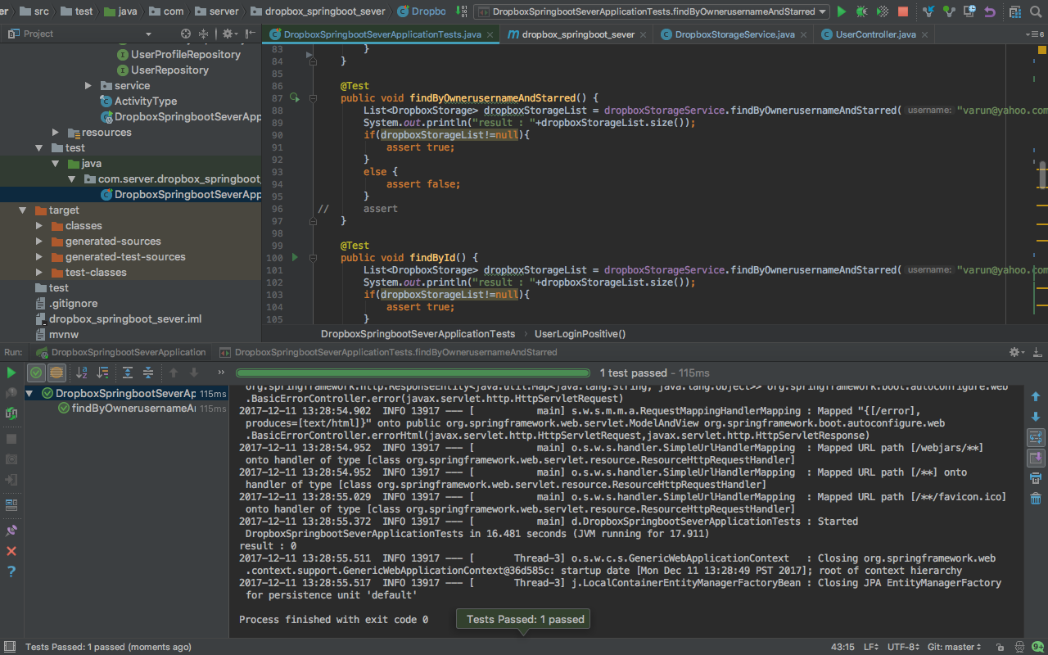

1. Find data by its id

* Test Output

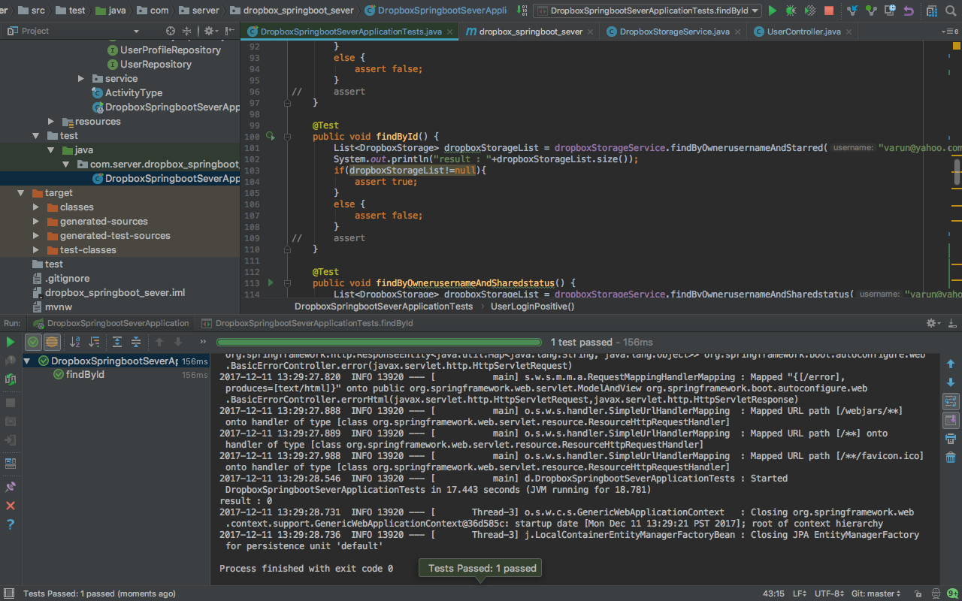

1. Find data shared by User

* Test Output

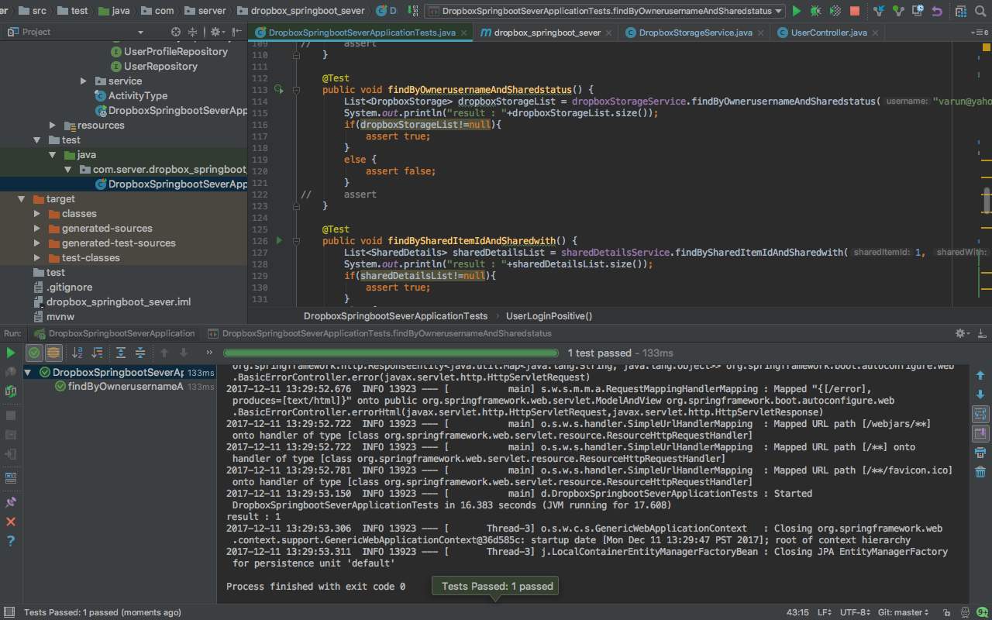

1. Find data shared with user

* Test Output

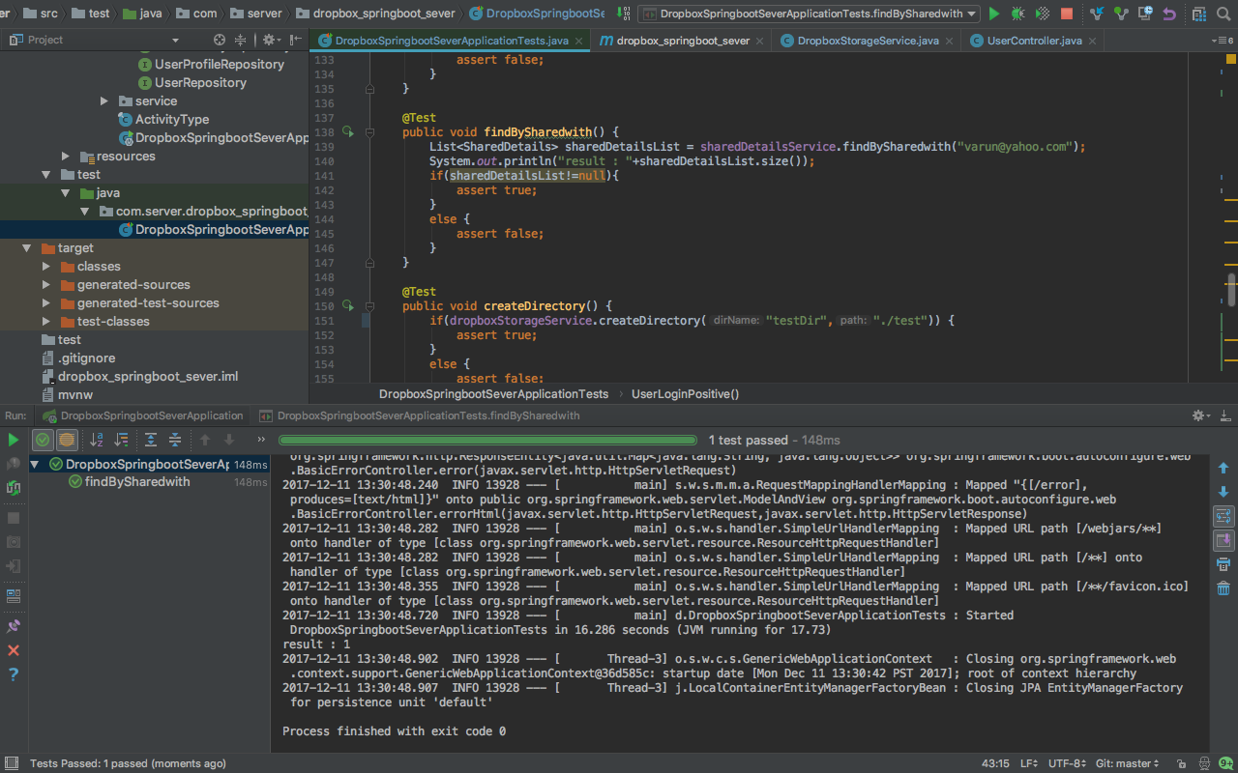

1. Create Directory

* Test Output

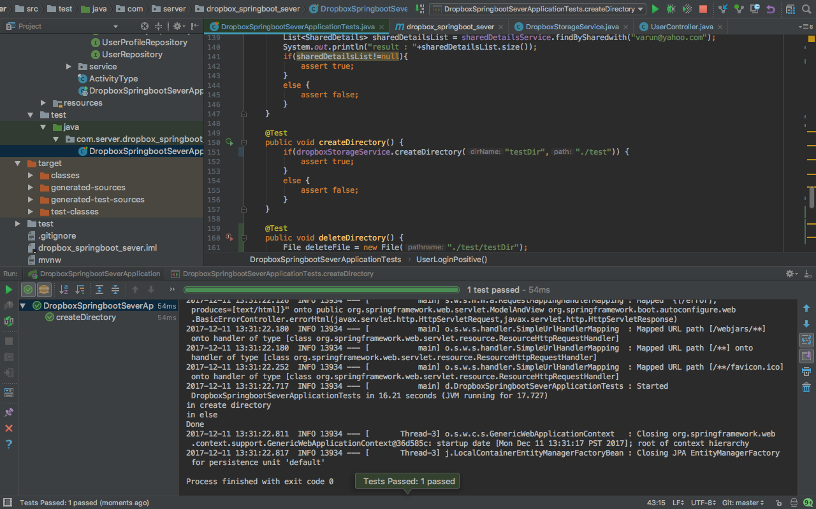

1. Delete previously created directory

* Test Output

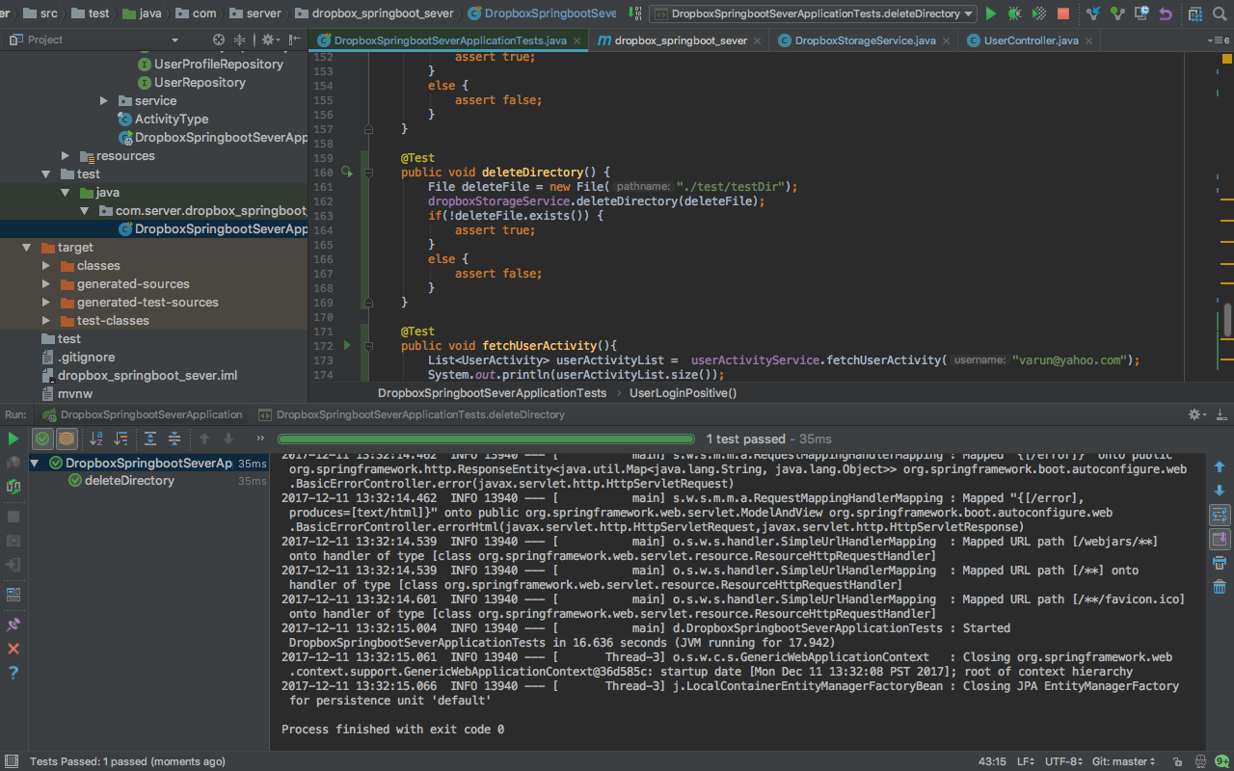

1. Fetch User Activity

* Test Output

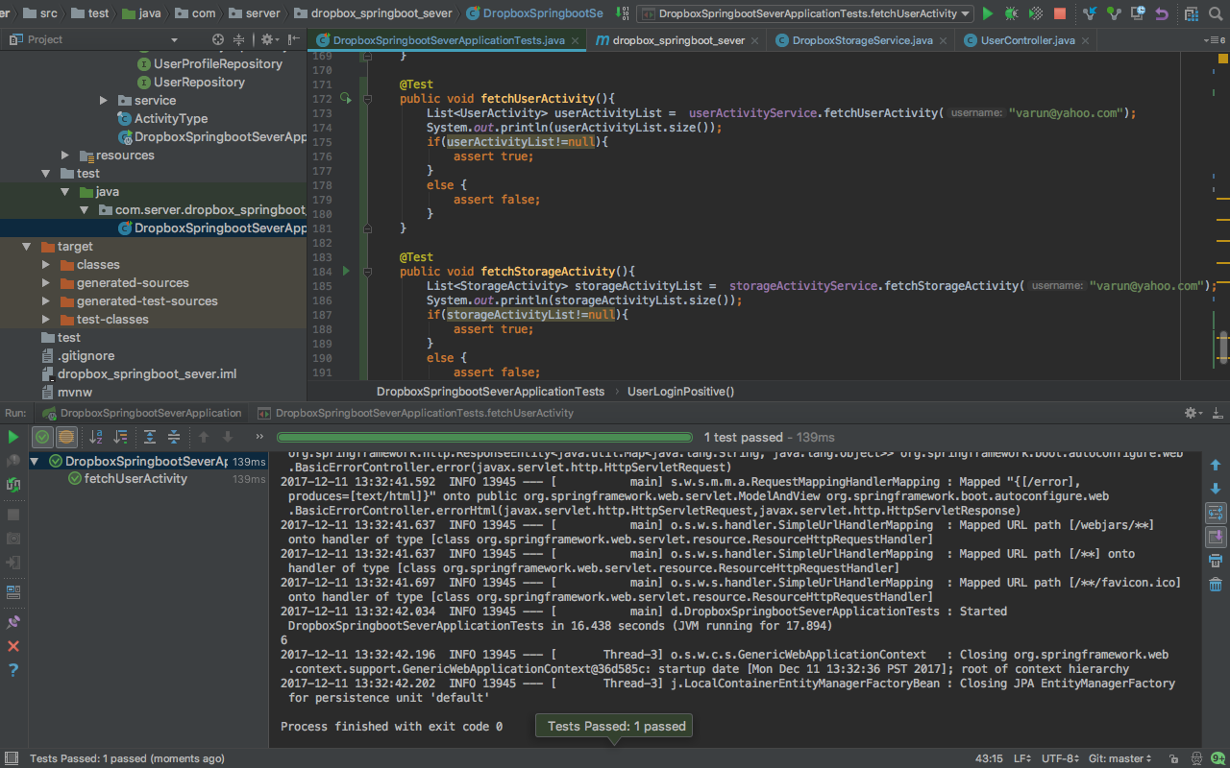

1. Fetch User’s Storage Activity

* Test Output

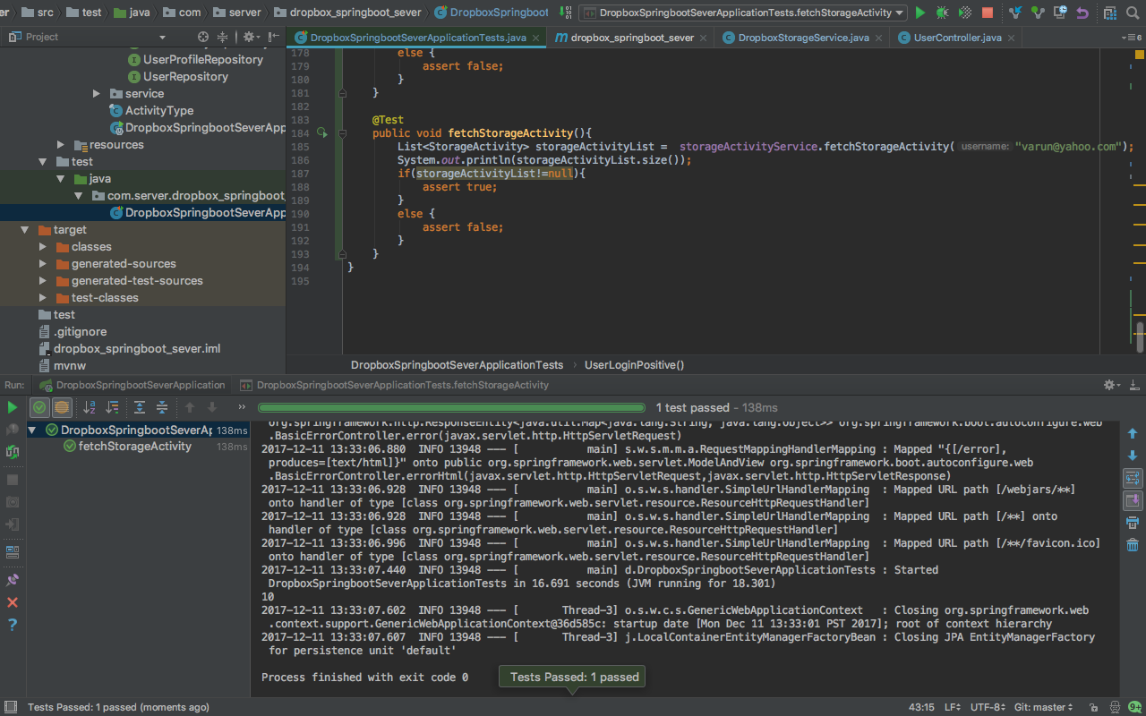

# GitHub Link

<https://github.com/varun1524/OnlineFileManagement_SpringBoot>